Name:___________________________________________________ Unit:_________________________ Date:_________ Pd:___
Practice: Microscopic Anatomy of Skeletal Muscle – PART 1
A & P Honors – Note that each image is a closer ZOOM IN than the previous
Important Vocab Defined:
- Epimysium:

- Perimysium:

- Fascicle:

- Muscle Fiber:
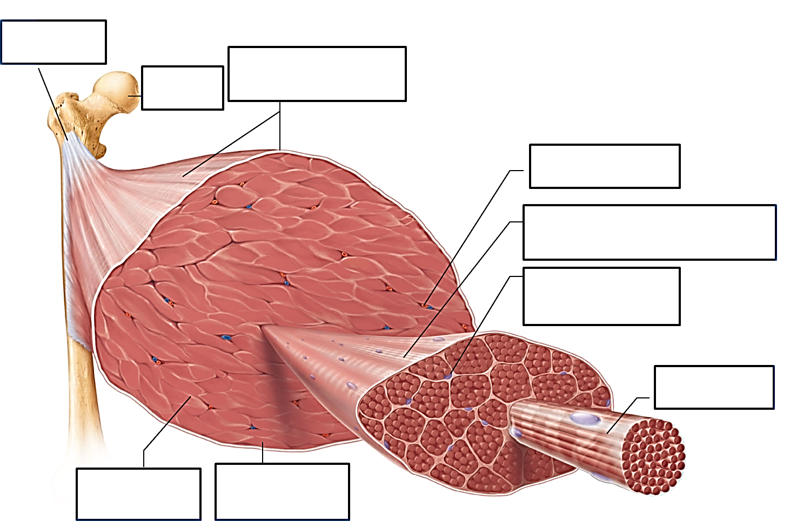

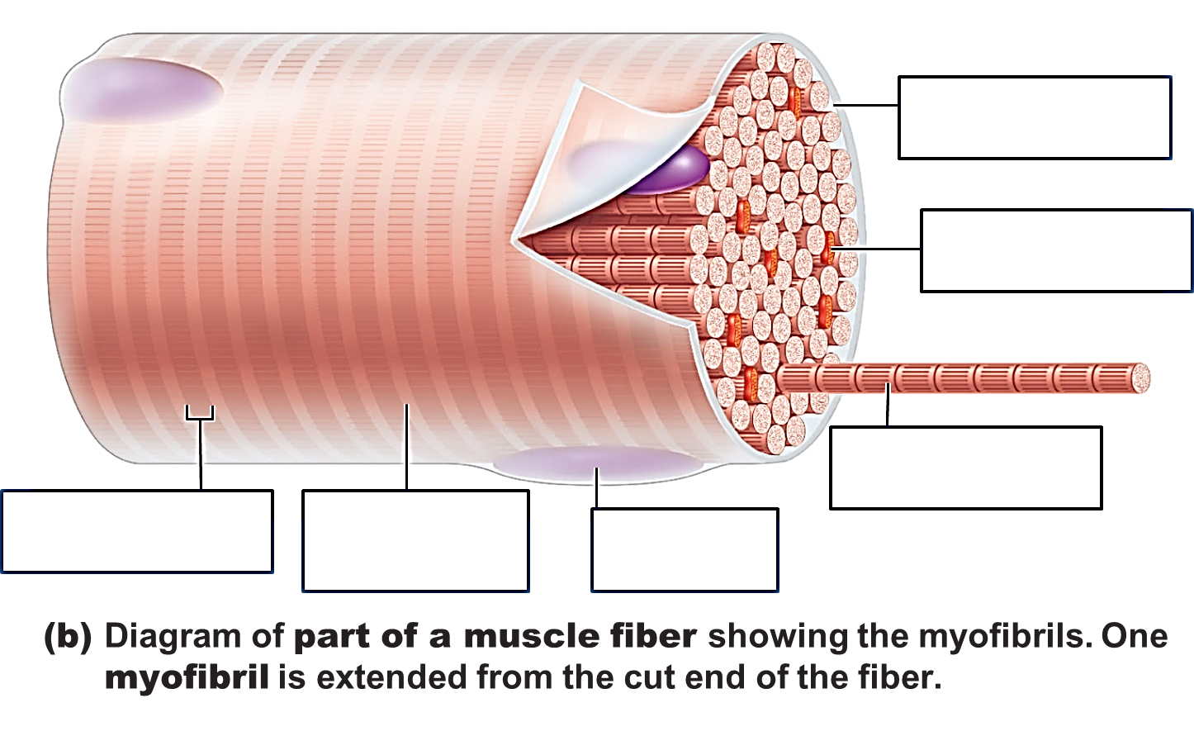

More Important Vocab Defined:
- Sarcolemma:

- Myofibril:

- Dark A Band:

- Light I Band:

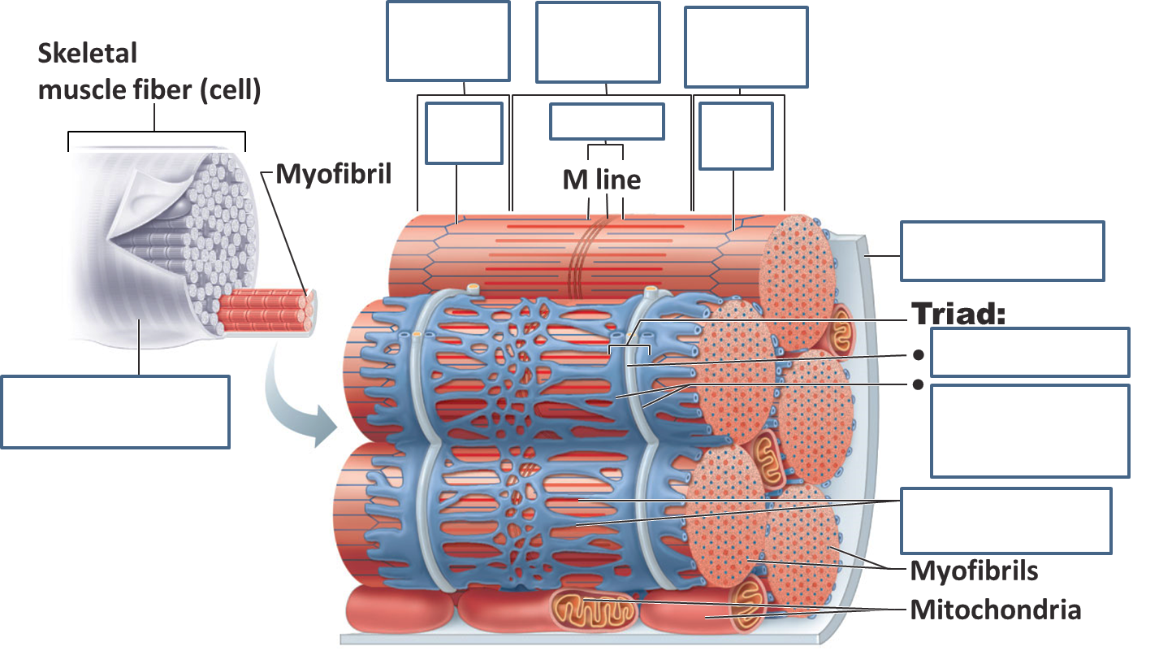
More Important Vocab Defined:
- Z- Disc:

- H – Zone:

- M – line:

- T- Tubule:

- Terminal cisternae of the SR (sarcoplasmic reticulum):
